Program Name: proj3Patel.docx

Programmer: Ishan Patel

Class: CSCI 2160

Date: March 22, 2014

1.)Display a menu

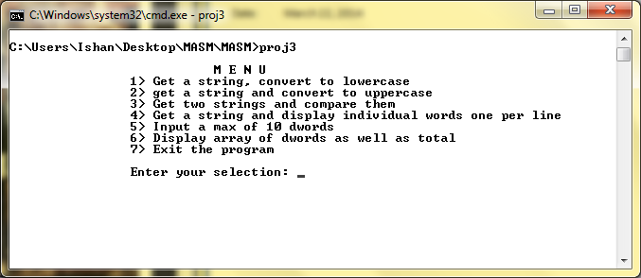

2.) choice 1: gets a string and display to lowercase

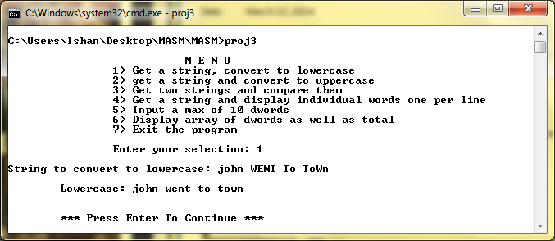

3) choice 2: gets a string and display a uppercase string

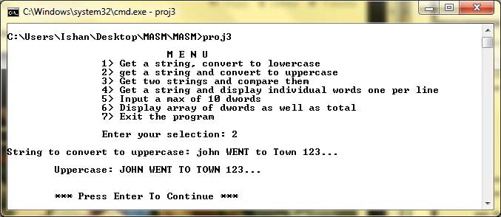

4.) choice 3: gets two string and compare them

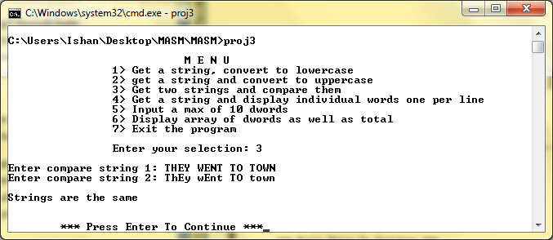

5.) choice 4: get a string and display one word per line

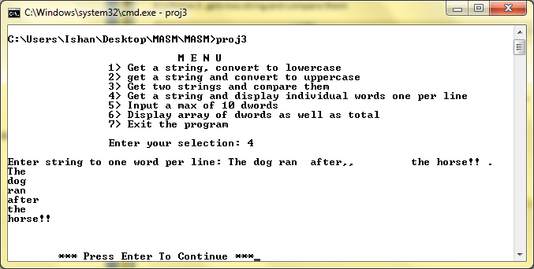

6.) choice 5. Input 10 dwords

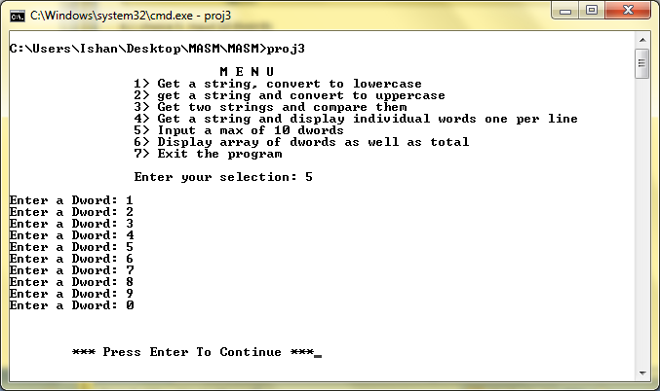

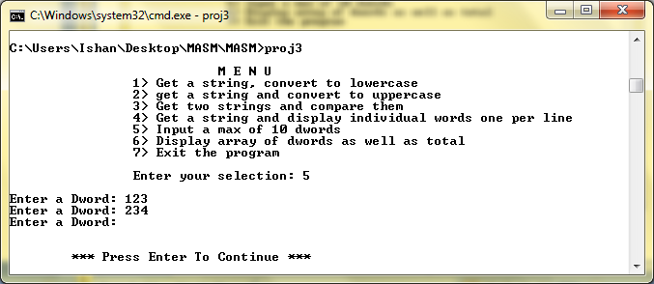

7.) choice 6: display all dwords and total of dwords

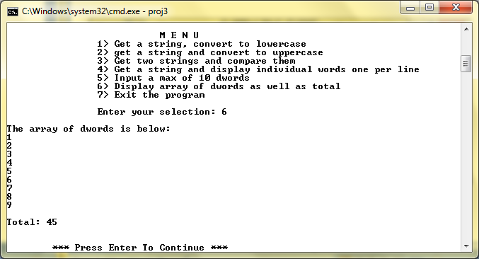

8.) choice 7: Exit the program

